

**The University of Azad Jammu and Kashmir, Muzaffarabad**

|  |  |
| --- | --- |
| Name | Kamal Ali Akmal |
| Course Name | Computer Architecture and Logic Design |
| Submitted to | Engr. Sidra Rafique |
| Semester | 2nd |
| Session | 2024-2028 |
| Roll No | 2024-SE-38 |
| Lab No | 03 |

Department of Software Engineering

**Procedure to Connect 7408 (AND Gate IC) in EWB**

**1. Open EWB Software**

* Start **Electronic Workbench** on your computer.

**2. Place the 7408 IC**

* Click on **Place** → **Component**.
* Go to the **TTL** or **Digital** library.
* Search and select **7408** (it’s the Quad 2-input AND gate).
* Place the 7408 IC onto the workspace.

**3. Connect the Power Supply**

* **Pin 14**: Connect it to **+5V** (power supply).
* **Pin 7**: Connect it to **Ground (GND)**.

This powers up the IC so it works properly.

**4. Set up Inputs**

* From **Inputs** menu, pick **Logic Switches**.
* Place **two switches** (one for each input).
* Connect:
  + One switch to **Pin 1** (Input A1).
  + One switch to **Pin 2** (Input B1).

**5. Set up Output**

* From **Indicators** menu, place an **LED**.
* Put a **330Ω resistor** in series with the LED (protects the LED).
* Connect:
  + **Pin 3** (Output Y1) → Resistor → LED → Ground.

**6. Start Simulation**

* Click **Run** (or Start Simulation button).

**7. Test the Circuit**

* Use the switches to turn inputs ON or OFF.
* Observe the LED:
  + LED **ON** = Output is HIGH (1).
  + LED **OFF** = Output is LOW (0).
* Try all combinations (00, 01, 10, 11) and record the results.

**AND GATE**

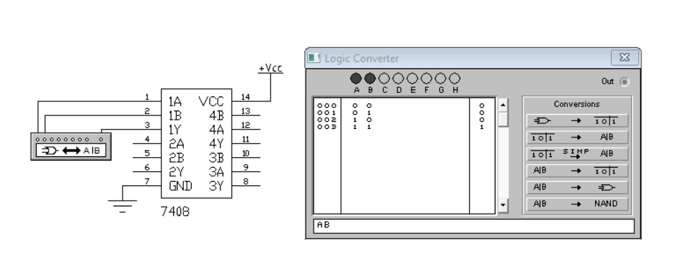 **Truth Table**

**Output**

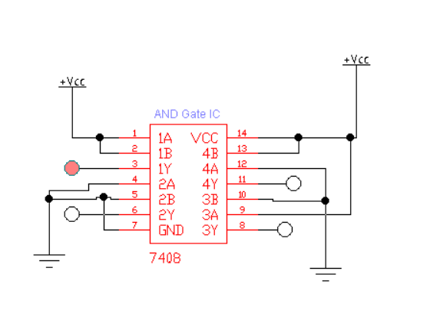

**Procedure to Connect 7432 (OR Gate IC) in EWB**

**1. Open EWB Software**

* Start **Electronic Workbench** on your computer.

**2. Place the 7432 IC**

* Click **Place → Component**.
* Find the **TTL** or **Digital** family.
* Search for **7432** (Quad 2-input OR gates).
* Place the **7432 IC** on your workspace.

**3. Connect Power to the IC**

* **Pin 14**: Connect to **+5V** (positive supply).
* **Pin 7**: Connect to **Ground (GND)**.

⚡ This step powers the IC so it can work correctly during simulation.

**4. Set Up Inputs**

* From the **Inputs** menu, place **two logic switches**.
* Connect:
  + First switch to **Pin 1** (Input A1).
  + Second switch to **Pin 2** (Input B1).

**5. Set Up Output**

* From the **Indicators** menu, place an **LED**.
* Add a **330Ω resistor** between the output and the LED.
* Connect:
  + **Pin 3** (Output Y1) → **Resistor** → **LED** → **Ground**.

**6. Start the Simulation**

* Click **Run** to start the simulation.

**7. Test and Observe**

* Toggle the switches through different combinations (00, 01, 10, 11).
* Watch the LED:
  + LED **ON** = Output is HIGH (1).
  + LED **OFF** = Output is LOW (0).
* Record the output to make your **truth table**.

**OR GATE**

**Truth table**

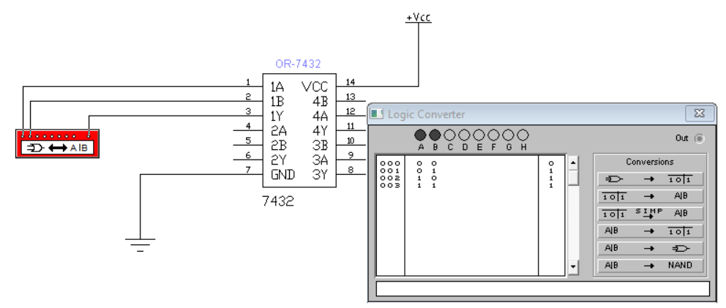

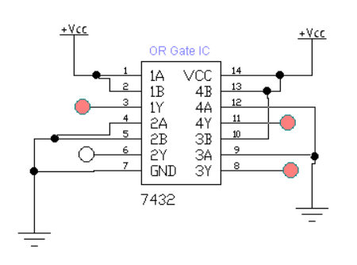**Output**

**Procedure to Connect 7400 (NAND Gate IC) in EWB**

**1. Open EWB Software**

* Start **Electronic Workbench** on your computer.

**2. Place the 7400 IC**

* Go to **Place → Component**.
* Find the **TTL** or **Digital** library.
* Search for **7400** (Quad 2-input NAND gate).
* Drag and place the IC on your workspace.

**3. Connect Power to the IC**

* **Pin 14**: Connect it to **+5V** (positive supply).
* **Pin 7**: Connect it to **Ground (GND)**.

⚡ This powers up the IC so it works properly in the simulation.

**4. Setup Input Connections**

* From the **Inputs** menu, place **two logic switches**.
* Connect:
  + First switch to **Pin 1** (Input A1).
  + Second switch to **Pin 2** (Input B1).

**5. Setup Output Connection**

* From the **Indicators** menu, place an **LED**.
* Add a **330Ω resistor** in series with the LED.
* Connect:
  + **Pin 3** (Output Y1) → **Resistor** → **LED** → **Ground**.

**6. Start the Simulation**

* Press the **Run** button to start the simulation.

**7. Test and Observe**

* Turn ON and OFF the switches in different combinations (00, 01, 10, 11).
* Watch the LED:
  + LED **ON** = Output is HIGH (1).
  + LED **OFF** = Output is LOW (0).
* Record the results for each combination to create the **truth table**.

**NAND GATE**

**Truth table**

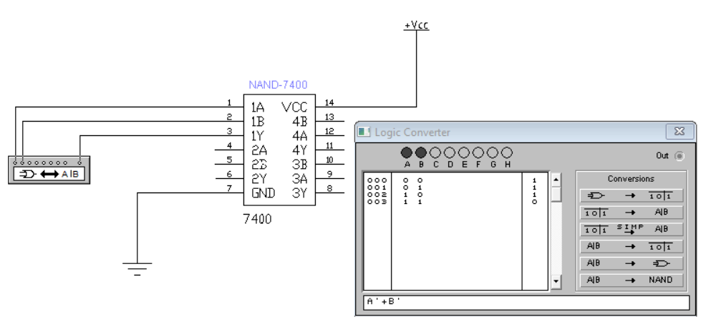

**Output**

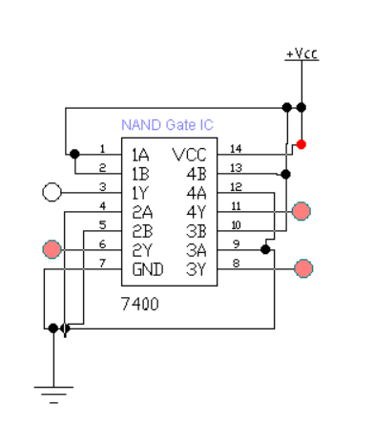

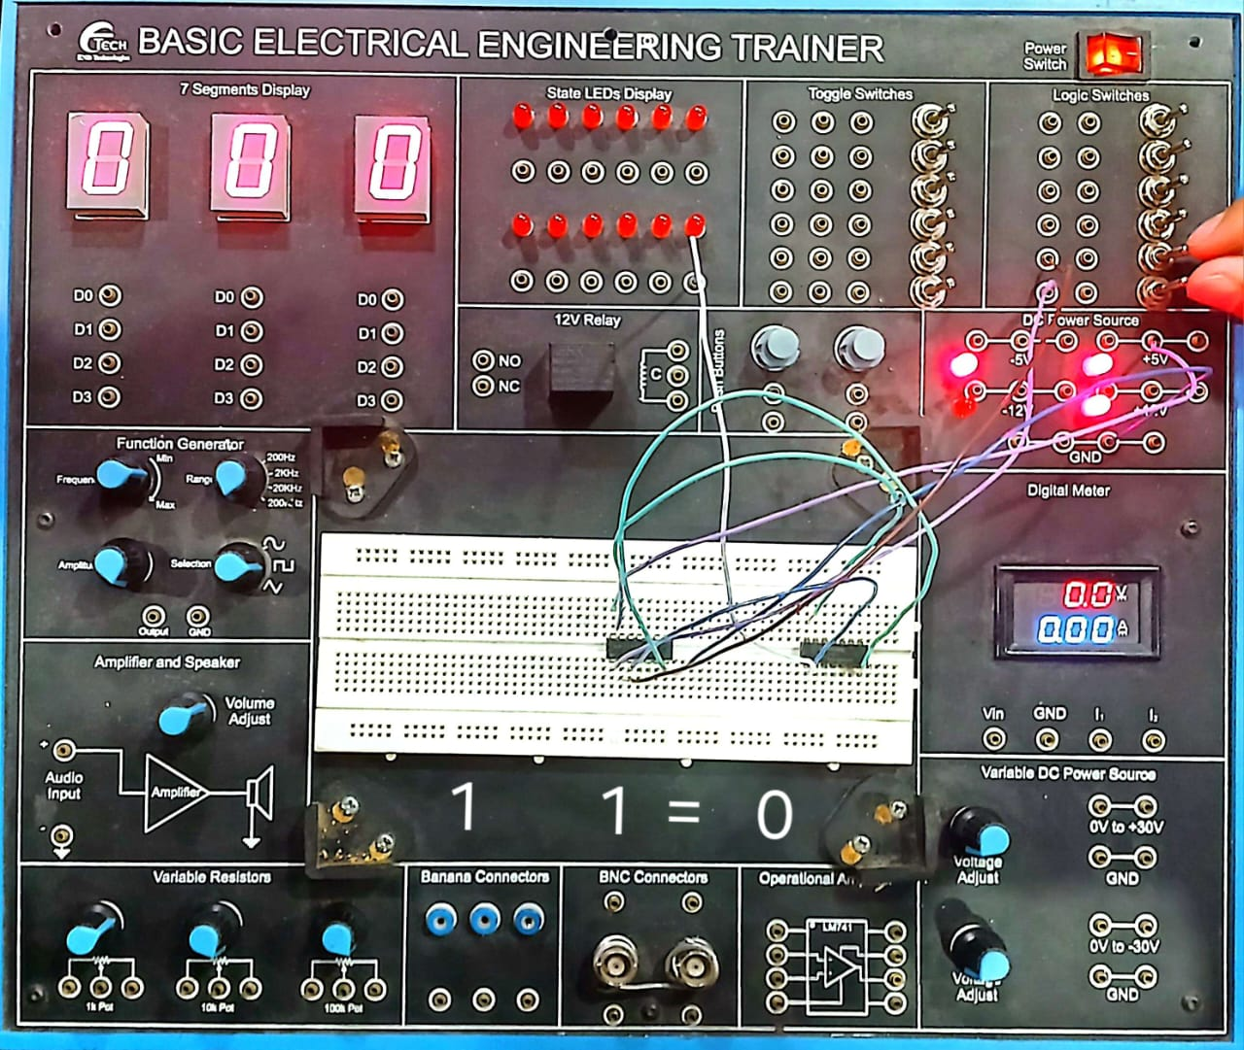

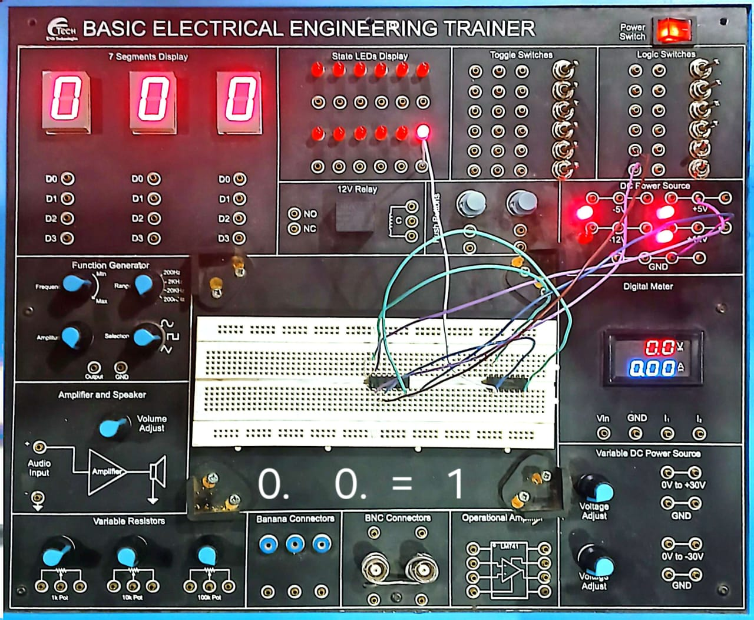

**Procedure to Connect 7402 (NOR Gate IC) in EWB**

**1. Open EWB Software**

* Start **Electronic Workbench** on your computer.

**2. Place the 7402 IC**

* Click **Place → Component**.
* Go to **TTL** or **Digital** library.
* Search for **7402** (Quad 2-input NOR gates).
* Place the **7402 IC** onto your workspace.

**3. Connect Power to the IC**

* **Pin 14**: Connect to **+5V** (positive power supply).
* **Pin 7**: Connect to **Ground (GND)**.

⚡ Powering the IC is necessary to make it work properly.

**4. Set Up Inputs**

* From the **Inputs** section, place **two logic switches**.
* Connect:
  + First switch to **Pin 1** (Input A1).
  + Second switch to **Pin 2** (Input B1).

**5. Set Up Output**

* From the **Indicators** section, place an **LED**.
* Add a **330Ω resistor** between the output and LED.
* Connect:
  + **Pin 3** (Output Y1) → **Resistor** → **LED** → **Ground**.

**6. Start the Simulation**

* Click **Run** to start the simulation.

**7. Test and Observe**

* Change the switches to different combinations (00, 01, 10, 11).
* Watch the LED:
  + LED **ON** = Output is HIGH (1).
  + LED **OFF** = Output is LOW (0).
* Write down the results to create the **truth table**.

**NOR GATE**

**Truth table**

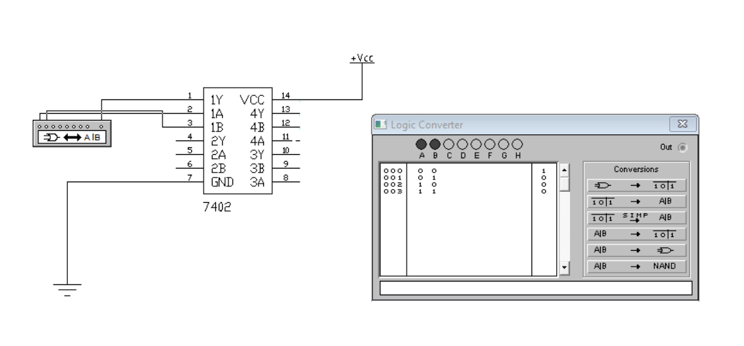

**Output**

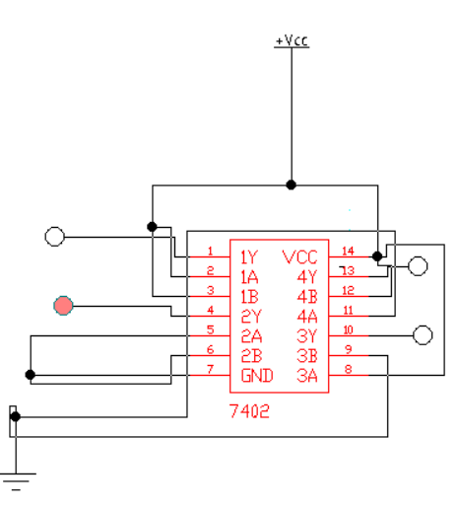

**Procedure to Connect 7404 (NOT Gate/Inverter IC) in EWB**

**1. Open EWB Software**

* Start **Electronic Workbench** on your computer

**2. Place the 7404 IC**

* Click on **Place → Component**.
* Find the **TTL** or **Digital** library.
* Search for **7404** (Hex Inverter/NOT gates).
* Place the **7404 IC** onto your workspace.

**3. Connect Power to the IC**

* **Pin 14**: Connect to **+5V** (positive power).
* **Pin 7**: Connect to **Ground (GND)**.

⚡ This step powers the IC so it works properly.

**4. Set Up Input**

* From the **Inputs** menu, place **one logic switch**.
* Connect the switch to **Pin 1** (Input A1).

**5. Set Up Output**

* From the **Indicators** menu, place an **LED**.
* Add a **330Ω resistor** between the output and LED.
* Connect:
  + **Pin 2** (Output Y1) → **Resistor** → **LED** → **Ground**.

**6. Start the Simulation**

* Click **Run** to start simulation.

**7. Test and Observe**

* Turn the switch ON and OFF (0 or 1).
* Observe the LED:
  + If input is **0** → LED turns **ON** (Output 1).
  + If input is **1** → LED turns **OFF** (Output 0).

**NOT GATE**

**Truth table**

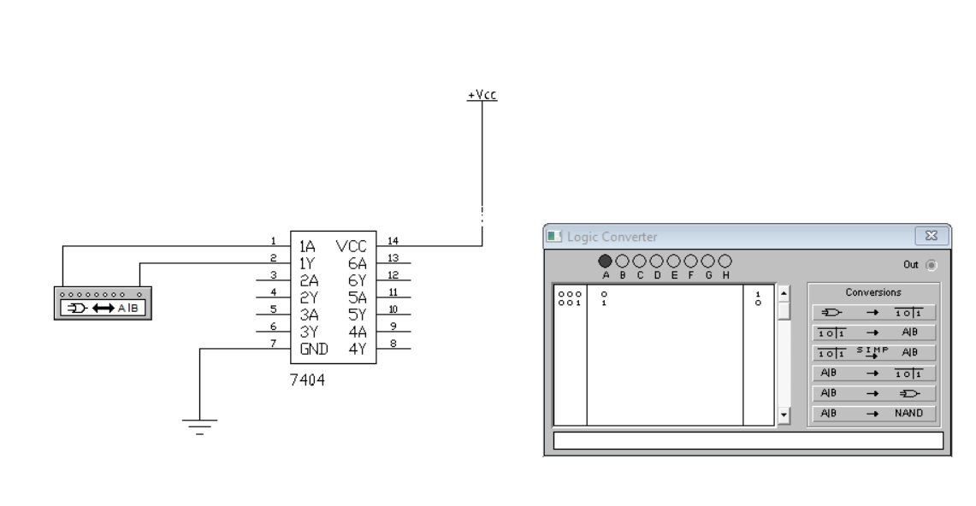

**Output**

